CHAPTER 2-6

regular expressions in java

- Suppose the data file number.txt contains the following 3 lines of integers separated by colons with no blanks in the file:
11:12:13
14:15
16

//Example 2-6-1
import java.util.Scanner;
import java.io.*;
class Demo
{
public static void main(String[] args) throws FileNotFoundException
{
int num=0, sum=0;
Scanner input = new Scanner(new File("number.txt")); //line 12
while (input.hasNextInt())
{
num = input.nextInt();
sum+=num;
}
System.out.println("The sum is "+sum);
}
}
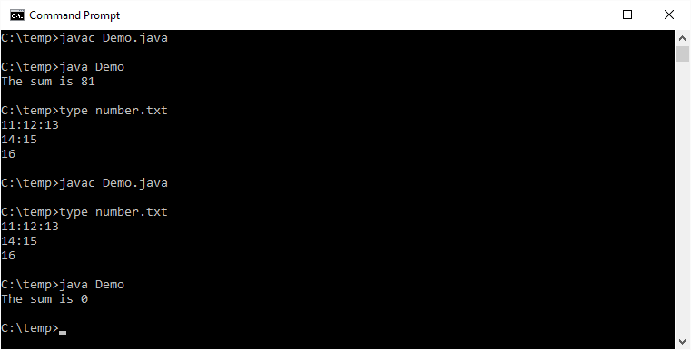

-----------------------------------------------------------------------------------------------------------------------
Usage: public Scanner useDelimiter(String s)
Post: This Scanner's token delimiters set to those characters matched by the string s. The argument s is treated as a regular expression.
Return: This Scanner object
-----------------------------------------------------------------------------------------------------------------------
Figure 21-1-1. Some useful members of the Scanner class.

Add the following line below line 12:
input.useDelimiter(":|[\r\n]+");
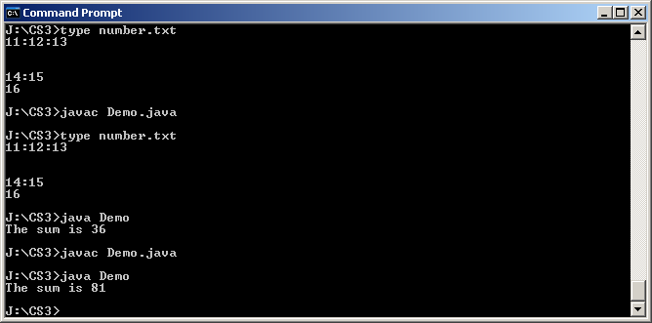

Java regular expressions

- A regular expression defines a set, which is a set of strings that matches the pattern specified by the regular expression.
  - Thus a regular expression defines a language.
- Different systems have different (although similar) notations used for specifying regular expressions.
- Regular expressions in Java:
  - Java regular expressions are expressed as strings.
  - Java regular expressions use [] or | for choices (instead of the union operator ∪)
    - a|b is the same as [ab]
    - a|b|c|d is the same as [abcd] which is the same as [a-d]
  - Java regular expressions use () for grouping.
  - Precedence, high to low
(), []
kleene *, kleene +
concat
union, i.e. |
- Some Java regular expressions
ab – ab
[ab] – a or b
a|b – a or b
a*b – 0 or more a's followed by 1 b
a+b – 1 or more a's followed by 1 b
ab+c* – 1 a followed by 1 or more b's followed by 0 or more c's
[ab]c – 1 a or 1 b followed by 1 c
[ab]+c – a string of a's and b's with at least 1 character followed by 1 c
[ab]*c – a string of a's and b's with at least 0 character followed by 1 c
[abc]|[xyz] – 1 a or 1 b or 1 c or 1 x or 1 y or 1z
[abc][xyz] – 1 a or 1 b or 1 c followed by 1 x or 1 y or 1 z
abc|xyz – abc or xyz
(abc)|(xyz) – abc or xyz
(abc)+|(xyz)* – 1 or more strings of abc or 0 or more strings of xyz

Class String

Usage: public String replaceAll(String old, String new)
Return: A new String whose contents are the result from replacing all occurrences of old (the longest such strings) in this String with new. Note: old is a regular expression; new is just a string

Usage: public String replaceFirst(String old, String new)
Return: A new String whose contents are the result from replacing the first occurrence of old (the longest such string) in this String with new. Note: old is a regular expression; new is just a string

//Example 2-6-2
//Demo.java
public class Demo
{
public static void main(String[] args)
{
String s= new String("aaabbb");
System.out.println(s.replaceAll ("ab", "AB"));
System.out.println(s.replaceAll ("a+b", "AB"));
System.out.println(s.replaceAll ("a*b", "AB"));
System.out.println(s.replaceAll ("[ab]", "AB"));
System.out.println(s.replaceAll ("(bb)|(aa)", "AB"));
System.out.println(s.replaceAll ("(aa)+", "AB"));
}
}
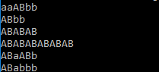

Special characters

//Example 2-6-3
//Demo.java
public class Demo
{
public static void main(String[] args)
{
String s= new String("3+4-5+6");
System.out.println(s.replaceAll ("+", "*")); //line 8
}
}
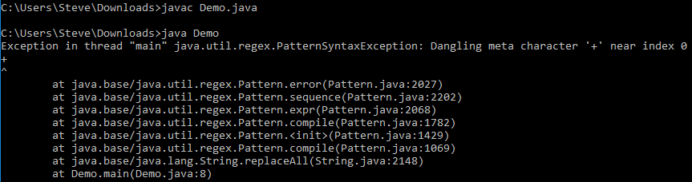

- As you can see, this program compiles but line 8 throws an exception when run. This is because as a string, "+" is legal and therefore the compiler allows it. But, as a regular expression, "+" is illegal and therefore s.replaceAll throws an exception.
- Replace line 8 by:
System.out.println(s.replaceAll ("\+", "*")); //line 8
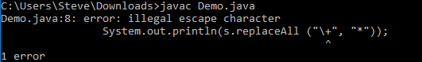

As you can see, line 8 does not compile. This is because as a string, "\+" is illegal since the escape sequence \+ is illegal and therefore the compiler does not allow it.
- Replace line 8 by:
System.out.println(s.replaceAll ("\\+", "*")); //line 8
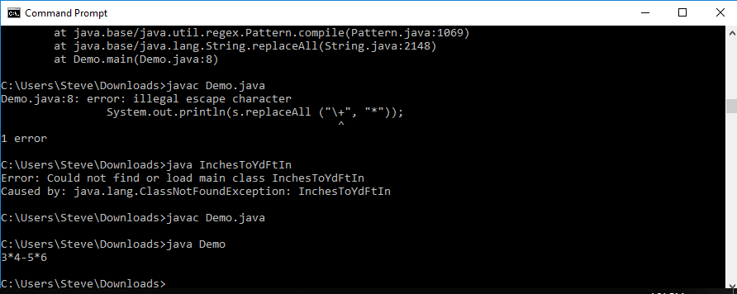

As you can see, everything is fine now. This is because as a string, "\\+" is legal, and the compiler replaces it by the sequence of characters <charcodeForBackSlash><charcodeForPlus>, which becomes the argument to replaceAll. As a regular expression, \+ escapes the normal meaning of + (which is 1 or more) and it matches literally the + character.

Class Matcher and class Pattern

- Java provides 2 classes, Pattern and Matcher, which programmers can use to match an input string to a particular regular expression. These 2 classes are in the package java.util.regex.
- To decide if the string "aaaaab" matches the regular expression "a*b", we can do the following:
Pattern p = Pattern.compile("a*b"); //compile the regular expression into a Pattern object
Matcher m = p.matcher("aaaaab"); //ask the Pattern object to create a Matcher object
//for matching the argument string
boolean b = m.matches(); //ask the Matcher object if we have a match

//Example 2-6-4
import java.util.regex.Pattern;
import java.util.regex.Matcher;
import java.util.Scanner;
class Demo
{
public static void main(String[] args)
{
Scanner keyboard=new Scanner(System.in);
Pattern p = Pattern.compile("a*b");
while (true)
{
System.out.print("Enter a string that matches a*b, or enter done to quit:");
String word = keyboard.nextLine();
if (word.equals("done")) break;
Matcher m = p.matcher(word);
if (m.matches()) System.out.println("matched");
else System.out.println("unmatched");
}
}
}
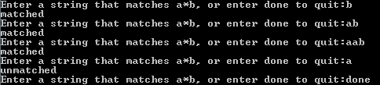

The 2-argument matches method of Class Pattern

- Consider the following statement:
boolean b = Pattern.matches("a*b", "aaaaab");
It is equivalent to the following 3 statements:
Pattern p = Pattern.compile("a*b");
Matcher m = p.matcher("aaaaab");
boolean b=m.matches();

//Example 2-6-5
import java.util.regex.Pattern;
import java.util.Scanner;
class Demo
{
//Input: A lastname
//Output:"Yes" if the lastname starts with J or j, "No" otherwise.
public static void main(String[] args)
{
Scanner keyboard=new Scanner(System.in);
while (true)
{
System.out.print("Type a lastname or enter done to quit:");
String lastname = keyboard.nextLine();
if (lastname.equals("done")) break;
boolean b = Pattern.matches("[Jj][a-zA-Z]*", lastname);
if (b) System.out.println("Yes");
else System.out.println("No ");
}
}
}
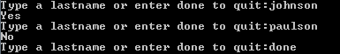

More special characters

- Java's regular expression extends beyond the formal definition of regular expression.
- The special character . matches any character.

//Example 2-6-6
import java.util.regex.Pattern;
import java.util.Scanner;
class Demo
{
public static void main(String[] args)
{
Scanner keyboard=new Scanner(System.in);
while (true)
{
String word = keyboard.nextLine();
if (word.equals("done")) break;
boolean b = Pattern.matches("a.a[a-z]*", word); //line 13
//matches any word whose first and third letters are a
if (b) System.out.println("Yes");
else System.out.println("No ");
}
}
}
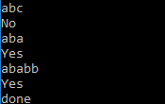

- The meta characters \b matches a word boundary.

//Example 2-6-7
//Demo.java
public class Demo
{
public static void main(String[] args)
{
String s= new String("This is the line");
System.out.println(s.replaceAll ("\b[Tt][a-z]*", "AA")); //line 8
}
}
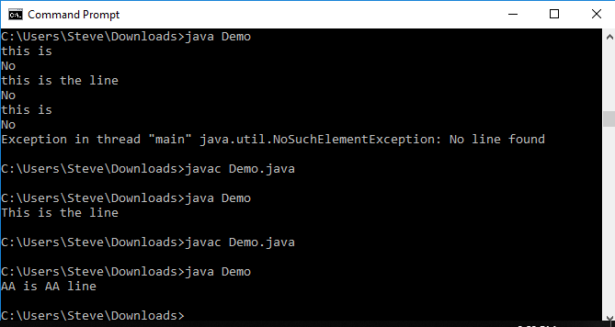

- It does not work. This is because the escape sequence \b is a legal escape sequence, and the compiler replaces it by <charcodeForBackspace>. Thus, it is the backspace character that replaceAll receives.
- Replace line 8 by:
System.out.println(s.replaceAll ("\\b[Tt][a-z]*", "AA")); //line 8
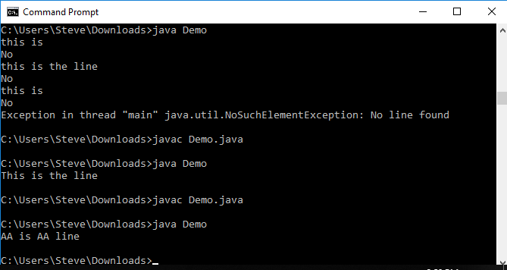

- Replace line 8 by:
System.out.println(s.replaceAll ("\\b[a-z]*e\\b", "AA")); //line 8
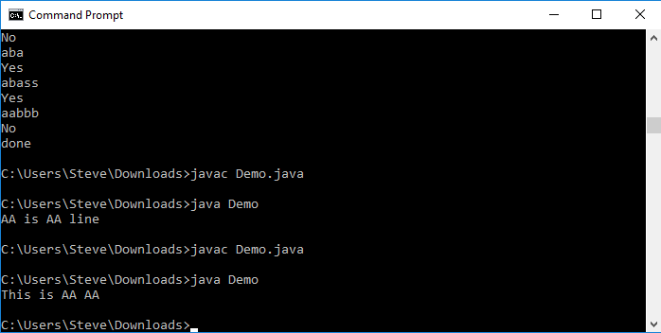

The find method of Class Matcher

-------------------------------------------------------------------------------------------------------------------
Usage: public boolean find()
Desc: Attempts to find the next longest substring of the sequence that matches the pattern. This method starts at the beginning of the sequence or, if a previous invocation of the method was successful and the matcher has not since been reset, at the first character not matched by the previous match.
Return: true if this Matcher finds a match, false otherwise. If it returns true, the matching substring can be extracted with an index range denoted by start() to end() of this Matcher.
-------------------------------------------------------------------------------------------------------------------
Figure 2-6-3. A useful method of class java.util.regex.Matcher.

- The find method scans the input sequence looking for the next subsequence that matches the pattern, while the matches method attempts to match the entire input sequence against the pattern.

//Example 2-6-8
import java.util.regex.Pattern;
import java.util.regex.Matcher;
import java.util.Scanner;
class Demo
{
//Desc: Extract from an input line all words that starts with J or j.
//Input: A line
//Output:All words that starts with J or j of the input line.
public static void main(String[] args)
{
Scanner keyboard=new Scanner(System.in);
String line, name;
Pattern p = Pattern.compile("[Jj][a-zA-Z]*"); //line 13
while (true)
{
System.out.println("Enter a line or enter done to quit.");
line = keyboard.nextLine();
if (line.equals("done")) break;
Matcher m = p.matcher(line);
System.out.println("Words start with J or j:");
while (m.find())
System.out.println("\t"+line.substring(m.start(),m.end()));
}
}
}
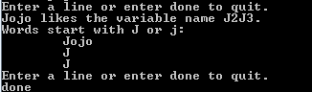

Pattern p = Pattern.compile("[Jj][a-zA-Z0-9]*"); //line 13

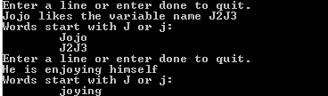

Pattern p = Pattern.compile("\\b[Jj][a-zA-Z0-9]*"); //line 13

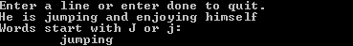

Building a concordance

- A concordance is a software tool that reads a text file and extracts all identifiers along with the line numbers on which the identifiers appear. (think about the index of a book)
- A concordance uses a TreeMap of <String, TreeSet<Integer>> entries. The identifier is the key, and the set of line numbers is the value. By using a TreeMap, we can list the identifiers in ascending order. By using a TreeSet as the value, we are assured that multiple occurrences of an identifier on a line are recorded only once and line numbers will be listed in ascending order.

//Example 2-6-9
import java.util.regex.Pattern;
import java.util.regex.Matcher;
import java.util.*;
import java.io.*;
class Demo
{
//A concordance. An identifier is defined to be an alphanumeric string that begins with a letter.
public static void main(String[] args) throws FileNotFoundException
{
Scanner keyboard=new Scanner(System.in);
System.out.print("Enter the file name: ");
String filename = keyboard.nextLine();
concordance(filename);
}
public static void concordance(String filename) throws FileNotFoundException
{
TreeMap<String, TreeSet<Integer>> m =new TreeMap<String, TreeSet<Integer>>();
int lineNumber = 0;
Scanner f = new Scanner(new File(filename));
Pattern p =Pattern.compile("[a-zA-Z][a-zA-Z0-9]*");
while(f.hasNextLine())
{
String s = f.nextLine();
lineNumber++;
Matcher matcher = p.matcher(s);
while (matcher.find())
{
String identifier = s.substring(matcher.start(),matcher.end());
TreeSet<Integer> lineNumbers = m.get(identifier);
if (lineNumbers == null ) lineNumbers = new TreeSet<Integer>();
lineNumbers.add(lineNumber);
m.put(identifier, lineNumbers);
}
}
writeConcordance(m);
}
public static void writeConcordance(TreeMap<String,TreeSet<Integer>> m)
{
Set<Map.Entry<String, TreeSet<Integer>>> entrySetObj=m.entrySet();
Iterator<Map.Entry<String,TreeSet<Integer>>> iter = entrySetObj.iterator();
while (iter.hasNext())
{
Map.Entry<String,TreeSet<Integer>> e = iter.next();
System.out.printf("%-20s", e.getKey());
TreeSet<Integer> lineNumbers = e.getValue();
System.out.printf("%4d:", lineNumbers.size());
Iterator<Integer> setIter = lineNumbers.iterator();
while (setIter.hasNext())
System.out.printf("%4d", setIter.next());
System.out.println();
}
}
}
- Suppose file concord.txt contains the following:
int m = 12, n = 14;
double a = 3, b = 2, hypotenuse

if (n <= 5)
n = 2*m;
else
n = m * m;
hypotenuse = sqrt(a*a + b*b);
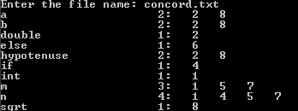

Programming exercises

Redo the concordance program with the following modifications:
- It must work with Java identifiers. In Java, an identifier consists of only underscores, dollar signs, letters, and digits which must not start with a digit.
- Multiple occurrences of an identifier on the same line must now be displayed. For example:
abc 5: 7, 11, 11, 12, 12

Submit in Google Classroom:
- Demo.java

